**HOME ABOUT SERVICES CONTACT**

<http://weaintplastic.com/>

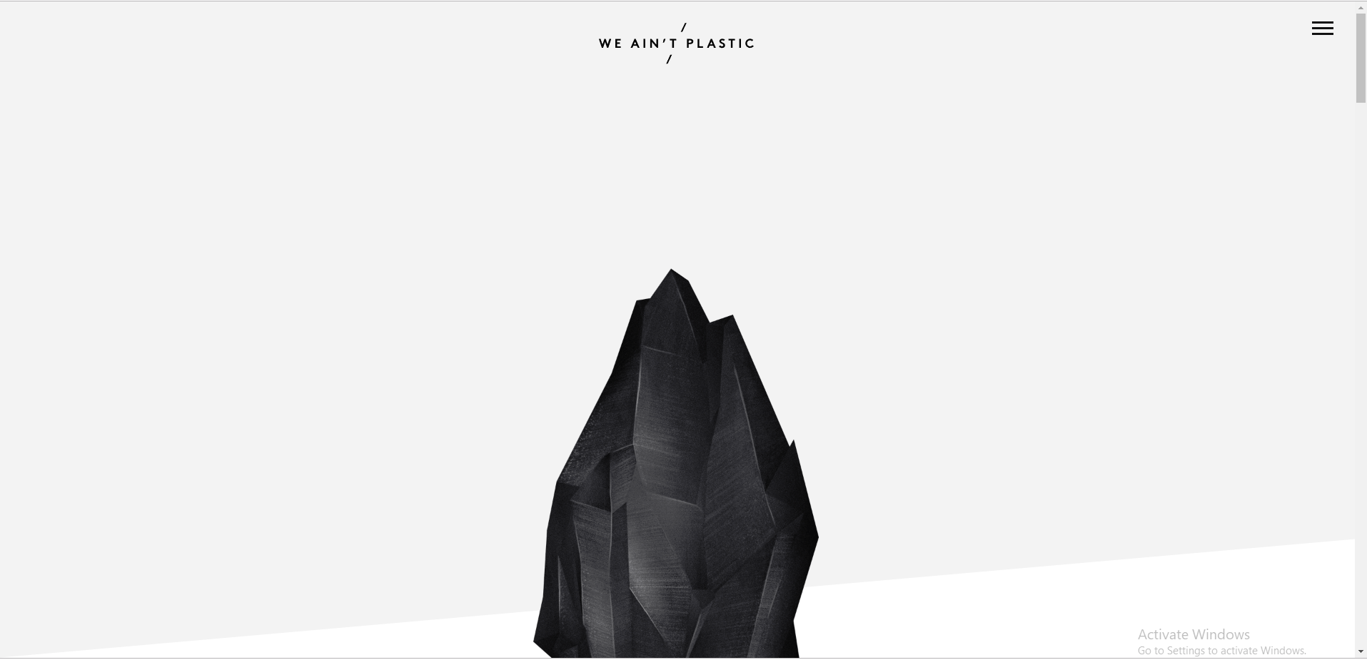

Instead of black gem stone add pictures – services. Reference website given below

<http://www.tanyagyani.com/>

content:

#Space planning

#3D Visualization

#INTERIOD DESIGN

#Modular furniture

#Home automation

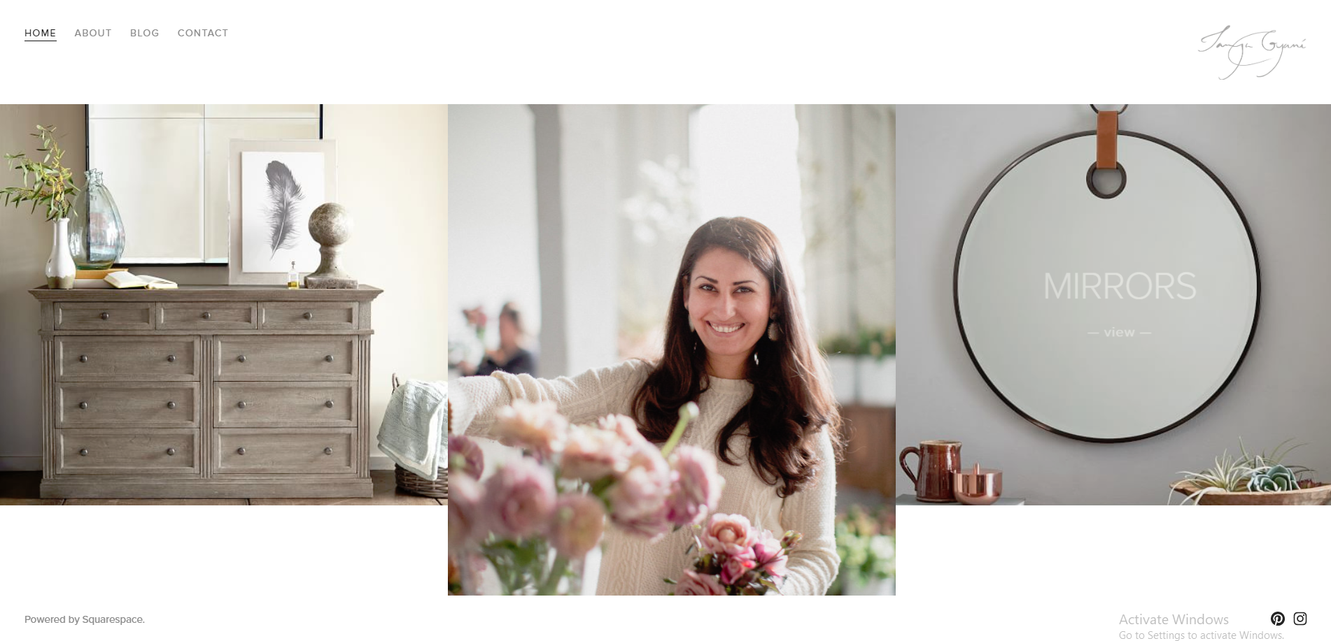

. If pictures are clicked, a info of that service should open like, given below.

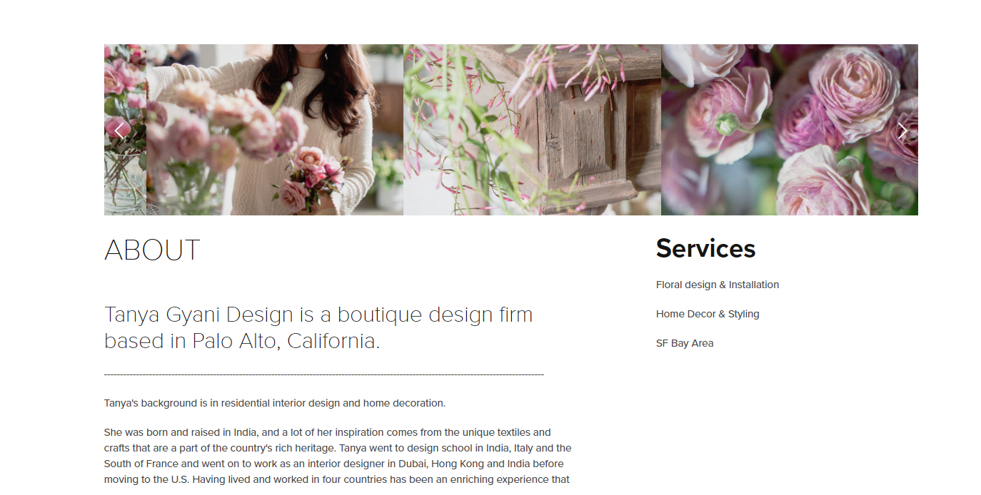

And below the services pictures, a tab showing “free site visit”

If clicking that the tab should go to “Be in touch” (contact) which will be at the end of home page.

Reference given.

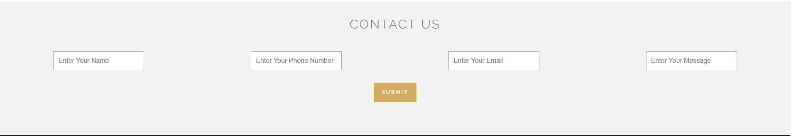

content:

#Space planning

Great interior designs start with space planning. If the room fails to meet the functionality – it really won’t matter how beautiful it looks. Just like any piece of furniture or the color of the walls, Space Planning makes a huge difference in the design of the room.

We make use of all the available space in an effective and efficient manner according to your requirements to maximize and improve the function and value of your property.

SERVICES

**Layout planning**

**Space Planning**

**Vasthu Consultation**

#3D Visualization

**We design the experience , you experience the designs !**

We provide you with the actual feel of the output through 3D visualization to ensure that the color, materials, finishes, furniture selection and lighting of your space provides comfort and elegance to your interiors. We make you see the unseen and shape your ideas to reality. We help you visualize the interiors of your home by capturing the moods, thoughts and life style.

SERVICES

**Residential**

**Commercial**

**Interior design**

**Façade design**

#INTERIOR DESIGN

**We believe that no two projects are same and one client’s space differs to a great extent with another’s, in terms of details and overall design**.

Our first step is to sit down with you and discuss in detail their specific requirements and vision for the space. This process not only helps you realize what you want but also helps us in bringing your imagination into reality. It provides you a clear vision and opportunity to get accurate and realistic information regarding the project because the clearer the vision, better the results.

We offer all interior services addressed from the scratch to the last finest detail.

SERVICES

## Interior Design Consultation

## Lighting & Soft Furnishings

## Indoor Plants

## Home Décor

## Turnkey Projects

#Furniture

The furniture design follows the design concept and theme tailored to your comfort and taste. we offer designs that provide you an organized and beautiful space. A lot of thinking and detailing goes into creating a furniture that serves everything from functionality and exquisite design. We pay attention to everything from layout to color to material selection to lighting, installation and custom furniture.

SERVICES

**Modular kitchen**

**TV Unit**

**Cabinets**

**Wardrobes**

**Sideboards.**

#Home automation

***Home automation made simple and affordable***

***Operate your appliances from your couch or from anywhere around the globe.***

***Put in your start temperature and the time you want your AC to be on. We'll take of the rest.***

***Have the convenience of a Smart Home on your fingertips.***

A Smart home system that understands and takes care of you like your very own personal assistant. Schedules your appliances, reminds you to switch them on or off, gives you the luxury to use them from anywhere, integrates with other smart assistants like Amazon Alexa, does everything for you at your command and wish.

SERVICES

**Control from Anywhere**

**Smart Scheduling**

**Effortless Living**

The KariGhars’ core value is to be able to decorate homes for families, just the way they want it to be. We believe “beauty” is a highly subjective concept. And every person seeks something different in the quest of beautiful. It’s not enough to create beautiful designs but to create designs that have a personal touch to them. We are recognized for our eclectic and emblematic designs but our main source of inspiration still remains you.

Young, energetic, passionate

I believe in the ability of art,architecture and design thinking to effect good in this world. To these ends I will continue to work, learn and immerse myself in these fields to create the best of my ability.

“Design décor and thoughts for **Functiona**l and **artistic spaces.”**

Avanga veetla oruthara irundu we will guide and design it.

B4 designing anytng we go thru a max possible ways in all aspects until we find the right one suiting the purpose. We design for the the space shown, its purpose, its usage, its surrounding, the person who is going to use that, their lifestyle, etc.we try to make the object not for the object but for the result, for the profit of human being.

Except the quote u can write anytng with this meaning.

Good lighting can lift a mood, make you reflective and make a difference to the way you think, act and feel. It is a key aspect of interior design and goes a long way in enhancing a space and its ambience. We make sure that we light up your space in a way that complements the look and ambience. When the right lighting is achieved, you will see your room transform into an exquisite combination of style and function.

Things addressed in the design scheme include: Furniture, fabrics, choice of paint shades, window treatment, rugs, lighting, and more.

Colors can be the most powerful design element, if they are used effectively. Colors have the ability to set a mood, attract attention or make a statement.

Color selection becomes very crucial as it is highly relative and cannot be prescribed. Each individual perceives and processes colors differently. Colors have been shown to affect us in numerous ways, both mentally and physically. Thus it is very important to get the colors right.

we discuss ideas and thoughts with our clients on different color .We then use colors consciously and harmoniously to create an enchanting ambience for you.